**SMART ENERGY MANAGEMENT SYSTEM**

**Motivation:**

The global population has increased significantly, with a surge of around 387% in the last century. This rise in population has led to an increased demand for energy production and consumption to meet the growing needs. Power consumption grew 9.5 per cent to 1,503.65 billion units year-on-year in 2022-23 while Power consumption was 1,374.02 billion units (BU) in 2021-22.

However, an inefficient distribution system has resulted in an oversupply of power to regions with lower demands, causing a shortage in areas with higher requirements According to the latest IEA data, the number of people around the world who live without electricity is 746 million and hundreds of millions have electricity for only a few hours.

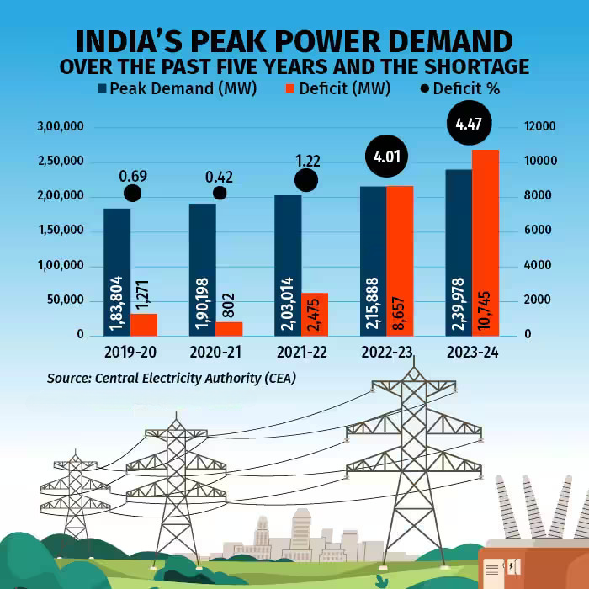

To predict future electricity demands and improve the power distribution system, it's crucial to analyse and forecast energy consumption. Estimating future energy needs helps optimise existing power grids, ensuring efficient energy use and reducing wastage. This optimization enhances efficiency and minimises unnecessary power loss, contributing to a more resource-efficient energy system.

**Problem Statement:**

From the past few years, total energy consumption for residential,industrial and commercial sectors has increased and it is growing as we can see in the graph. But the problem is daily energy consumption is not the same as the generated energy or predicted energy, that leads to energy wastage, increasing cost and more carbon footprint.

To tackle fluctuating energy demand and wastage, an efficient algorithm leveraging data analytics and machine learning can be developed. By analysing previous consumption patterns, weather data, and infrastructure status, the algorithm predicts daily demand more accurately.It also integrates optimization strategies to minimise wastage and reduce carbon footprint. Continuous monitoring ensures feedback for improvement, ultimately enabling better resource management, cost reduction, and environmental mitigation.

This can be solved in places where there is overconsumption(pollution caused by the overuse of fossil fuels), increasing energy demand due to overpopulation, enhancing poor infrastructure as it uses high energy, energy waste etc.

**Literature Survey:**

As solar power becomes more affordable for homes, many people are choosing to install solar panels to save money on energy bills and help the environment. But there's a problem: solar power isn't always available when we need it most. For example, during the day when the sun is shining, we might generate more solar power than we can use. But at night when we need electricity the most, solar panels aren't producing anything.To solve this issue, some people add batteries to store extra solar power generated during the day so they can use it later.

From a customer's perspective, **the main goal is to minimise costs and maximise the benefits** of their energy system. This involves finding the right balance between the size of the storage devices and the solar panels based on how much electricity the household uses.

Some studies have looked into using a method called **Dynamic Programming** to figure out the best size for energy storage devices. This method helps find the most efficient solution to problems, like preventing power outages or managing household electricity use.

This work proposes a DP based control strategy for smart homes with solar energy generation and storage. The aim is to maximise savings on grid electricity purchases by managing storage with various combinations of solar panel sizes and storage capacities. DP results are used to calculate Net Present Value (NPV), helping determine the optimal combination of PV panel size and storage capacity while factoring in investment costs.

The problem is built upon the following assumptions:

1. The household can only receive power from the grid. There's no sending excess energy back to the grid, and no compensation is given for surplus energy (net metering).

2. The storage system can only be charged from solar panel generation and discharges solely to power the household's

needs.

DP serves as an optimal control technique for tackling intricate issues by breaking them down into smaller, more manageable sub-problems. It relies on Richard Bellman's principle, which guarantees global optimality. DP is rooted in the Hamilton-Bellman-Jacobi (HBJ) equation. DP is utilised to solve the optimal operation of dispersed energy systems for customers, while a successive approximation method is employed for optimal power flow operation in the distribution network.

**Proposed Solution:**

**Heuristic Approach**

**Sequential Modelling**

LSTM networks excel in modelling time-dependent energy consumption data, capturing both short-term fluctuations and long-term trends. Their memory cells enable storage of information across multiple time steps, accommodating irregular patterns due to factors like weather changes or holidays. Their adaptability allows for accurate forecasting by dynamically updating internal states in response to new input.

#### **Data Preprocessing**

This involves cleaning the data, handling missing values, normalisation, and feature engineering. In the context of energy management, data preprocessing may include converting raw energy consumption data into appropriate formats and identifying relevant features such as time of day, energy unit values.

#### **Model Architecture**

We propose the utilisation of LSTM architectures for energy consumption prediction. LSTM, with its ability to capture long-term dependencies and handle vanishing gradient problems, is particularly well-suited for time series forecasting tasks such as energy consumption prediction.

#### **Training Process**

The training process involves feeding historical energy consumption data into the sequential models to learn patterns and correlations. We employ techniques such as mini-batch gradient descent and backpropagation through time to optimise model parameters. By feeding the data of day *d1 ,d2 …. dn* our model will forecast the consumption on day *dn+1.*

**Evaluation Metrics**

To assess the performance of the proposed solution, we would be using various evaluation metrics such as Mean Absolute Error (MAE), Root Mean Square Error (RMSE). Additionally, graphical representations such as time series plots and residual plots can provide insights into the accuracy and consistency of predictions.

**LSTM Memory Cell**

* **Forget Gate:**
  + **Function:** Decides which past information to retain or forget within the LSTM cell state.
  + **Relevance to Energy Consumption Prediction**: Enables adaptation to changing consumption patterns by discarding outdated data, allowing the model to focus on recent trends and patterns.
* **Input Gate:**
  + **Function:** Controls the flow of new input information into the LSTM cell state.
  + **Relevance to Energy Consumption Prediction**: Allows the model to prioritise relevant factors such as time of day, ensuring that only significant information influences predictions while filtering out noise.
* **Output Gate:**
  + **Function:** Determines what information from the LSTM cell state is used for prediction.
  + **Relevance to Energy Consumption Prediction:** Ensures that the model outputs relevant information for forecasting future energy consumption accurately, capturing both short-term fluctuations and long-term trends effectively.

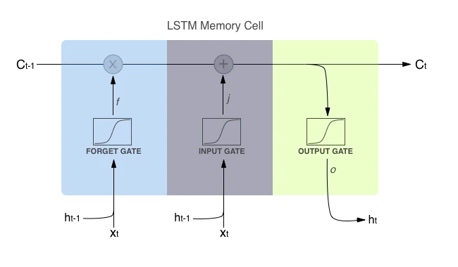

**Dynamic Programming Approach**

**Objective:**

Design an excellent timetable for producing energy and managing demand in a smart grid. We aim to minimise the energy cost while ensuring the grid remains stable and users are comfortable. This involves utilising sophisticated tools like LSTM for predicting demand and DP for cost optimisation.

**Problem Formulation:**

* We aim to minimise the total cost of energy procurement for the intelligent grid, considering various factors:
* Predicted demand: Obtained from the trained LSTM model for different time horizons (e.g., hourly, daily).
* Available energy generation: This includes capacity and cost information for different sources like:
  + - Renewable sources: Solar, wind, etc. (variable output)
    - Dispatchable sources: Fossil fuels, hydro, etc. (adjustable output)
* Dynamic energy prices: Real-time market prices for electricity can fluctuate based on supply and demand.
* User comfort constraints: Minimum power delivery levels must be maintained for essential services like hospitals.

**State Definition:**

At each time step, the state of the system can be defined by a set of variables, including:

* Current energy demand
* Available generation capacity from each source
* Time of day and day of the week (affects demand patterns)

**Action Definition:**

The available actions represent decisions the system can make at each time step:

* Dispatching different generation sources: Determine the amount of power generated from each source (e.g., increase solar power and activate a natural gas plant).

**Objective Function:**

The objective function calculates the total cost associated with each action at each time step. This includes:

* Generation cost: The cost of generating electricity from each source is based on its operational cost and efficiency.
* Dynamic energy purchase cost: If the grid needs additional power, purchasing it from the real-time market is expensive.
* Cost of implementing demand-response programs: This could include administrative costs and potential compensation to consumers for participating.

**Bellman Equation and DP Algorithm:**

The Bellman equation is used iteratively to find the optimal sequence of actions that minimises the total cost over the entire planning horizon. It utilises the following steps:

1. Start at the final time step:
   1. Calculate the cost for each possible action at this time step considering the final state and objective function.
2. Work backward through time steps:

For each previous time step:

* + 1. For each possible state, consider all possible actions.
    2. Calculate each action's immediate cost (from the objective function) and the expected future cost. The expected future cost is the minimum cost achievable from the next step onwards, considering the resulting state after taking the current action.
    3. Choose the action leading to the minimum sum of immediate and expected future costs.

1. Backward recursion:
   1. Repeat step 2 until reaching the initial time step.

By applying the Bellman equation and DP algorithm, the system iteratively finds the optimal sequence of actions for each time step, minimising the total cost of energy procurement while satisfying demand and user comfort constraints.